Exercise 1: **TOP 5 CHANNELS**

The hypotheses:

Adding trust-inducing copy on the email, phone and opt-in fields at checkout will lead to an increase in transactions.

Test run dates: 10/18/19- 10/31/19

Device : Desktop, Mobile

I am further exploring the New Users and the Returning Users to see if the test results in increase in transactions or conversions.

For each combination of Dimensions and Metrics, I am doing a descriptive analysis and also applying Linear Regression to the test period data to determine the statistical significance.

A linear regression is say like :

Y ~ aX1 + bX2 + cX3 +ε

The concept of Linear Regression is determining the proportion of variation of the dependent variable (Y), due to independent variable(predictors) X1 or X2 or X3.

P-values and coefficients(a, b or c) in regression analysis work together to tell which relationships in the model are statistically significant and the nature of those relationships.

The coefficients describe the mathematical relationship between each independent variable and the dependent variable. Each regression coefficient is independent of all the other predictors. If ‘a’ is positive, then for every one unit increase in X1, Y increase by ‘a’. On the other hand, if ‘a’ is negative, for every one unit increase in ‘a’, Y decreases by ‘a’ unit.

The null hypothesis of the model is that predictors are insignificant. If P value is <0.05 it means that there is very less probability that the predictor is insignificant, so we reject the Null.

In the following analysis, I am considering p-values to determine the statistical significance for the predictors **in the test period**.

Steps on Google Account:

1. View- Test View
2. Select a date range. pre-event Oct 4th to Oct 17th :post-event- Oct 18th – Oct 31st
3. Pick segment : New Users.
4. Pick segment : Returning Users

**Conversions: eCommerce**

**#1. New Users. Dimensions**: Channel, **Metrics**: New Users

**Returning Users. Dimensions**: Channel,  **Metrics**: Users

**Figure 1**

For New Users Organic Search, Direct, Referral, Other and Social are the top preferred channels. Organic and Direct search did get the boost in the test period.

For Returned Users Organic, Referral, Direct, Other and Branded Paid Search are the preferred channels. All of them got an increased number of Users during the test period.

**#2. New Users. Dimensions:** Channel **Metrics:** Sessions

**Returning Users Dimensions:** Channel **Metrics:** Sessions

**Figure 2**

For the New Users, the increased Sessions were in Organic, Direct, Referral, Other and Social.

For the Returning Users, the increased Sessions were in Organic, Referral, Direct, Other and Branded Paid Search.

We see an increase in sessions for both users for Organic and Referrals.

**#3. New Users. Dimensions:** Channel **Metrics:** Bounce Rate

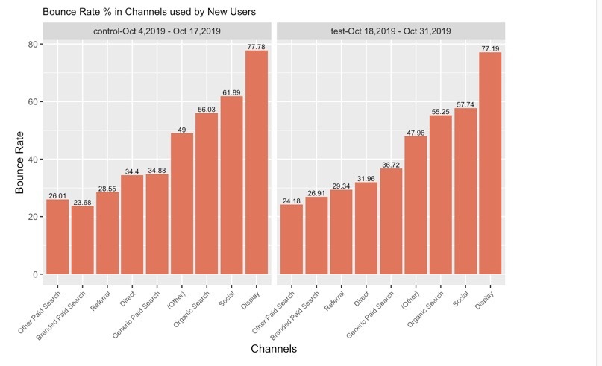

**Returning Users Dimensions:** Channel **Metrics:** Bounce Rate

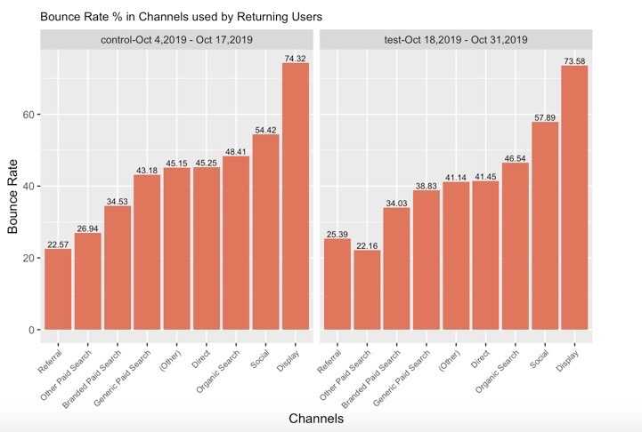

**Figure 3**

The bounce rate is generally a bit lower in the test period for both New and Returning Users, which could possibly have increased the transactions in the test period. The bounce rate is the highest in Display channel.

**#4. New Users. Dimensions:** Channel **Metrics:** Revenue

**Returning Users. Dimensions:** Channel **Metrics:** Revenue

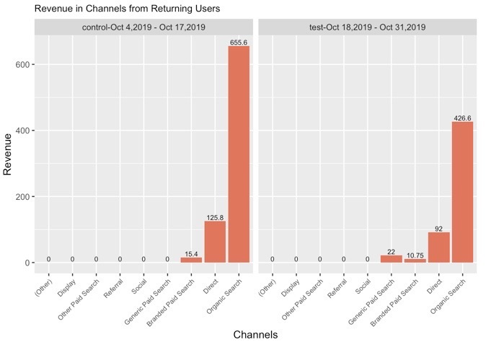

**Figure 4**

Overall the Revenue has dropped in test period.

In the test period, there was increase in revenue for New Users for Channels Organic, Generic and Branded Paid Search. For the Returned users only, Generic paid search had slight increase in revenue.

**#5. New Users. Dimensions:** Channel , City **Metrics:** New Users

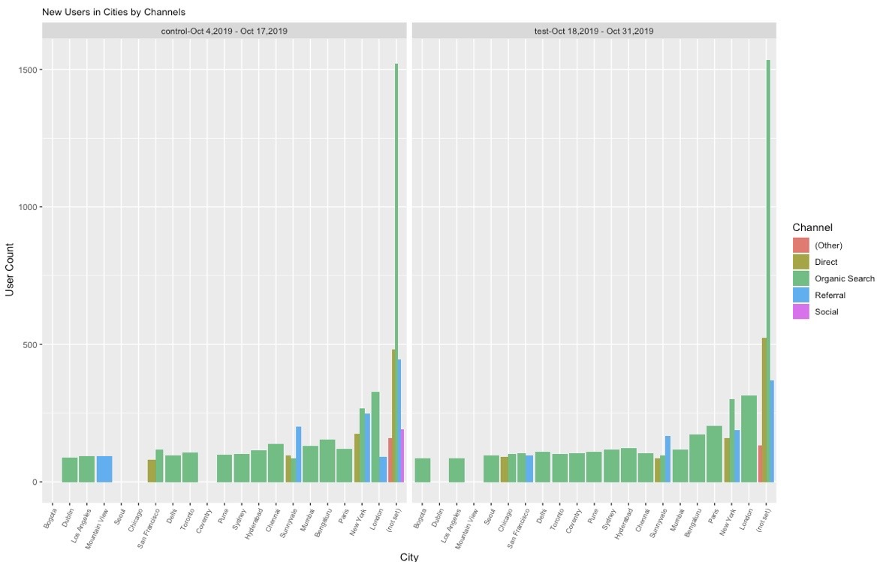

While regressing the test data for New Users, to determine the statistical significance, the following cities are significant in Revenue variation. Variables New Users and Transactions are also significant.

**Returning Users. Dimensions:** Channel , City. **Metrics:** Users

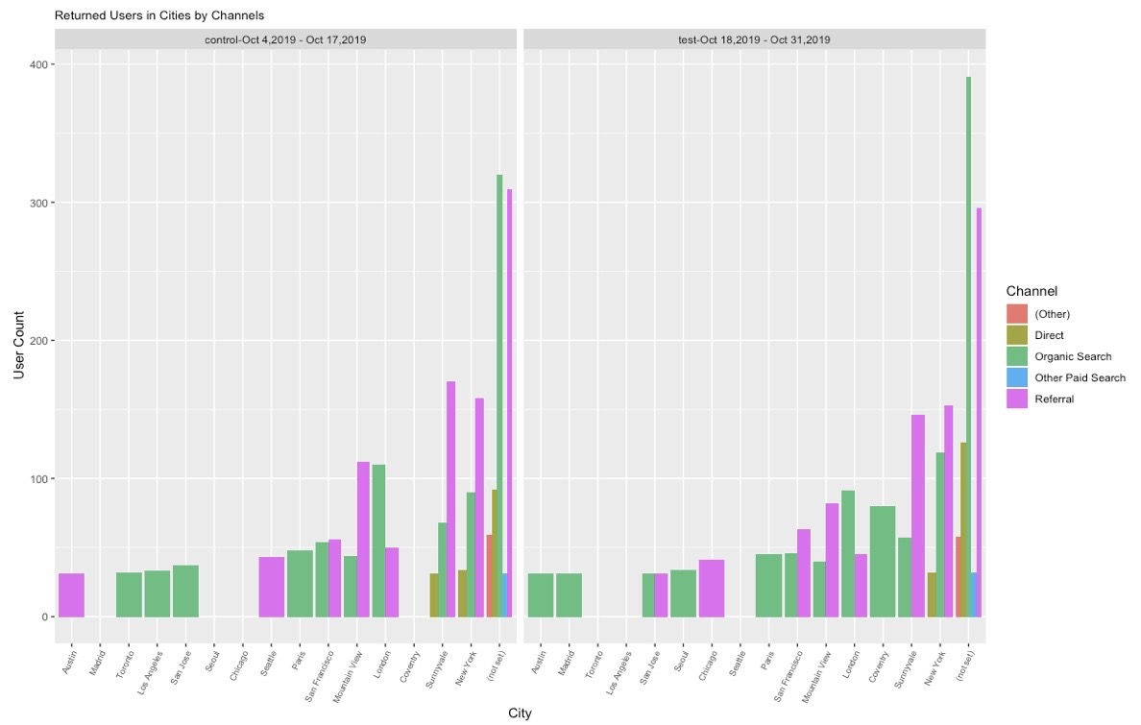

While regressing the test data for Returning Users, Channel Branded Paid Search is significant in Revenue variation. The following cities are also significant along with Transactions .

**Figure 5**

Overall, there is an increase in the number of users in cities in test period. Organic search is most prevalent for New Users, while Referral and Organic are the most preferred by Returned Users. The city “notset” has the highest number of New and Returned Users.

**#6. New Users. Dimensions:** Channel , Country. **Metrics:** New Users

While regressing the test data for New Users, to determine the statistical significance, the Channels Branded Paid Search, Generic Paid Search, Countries -Canada and United States are significant along with New Users and Transactions in variations in Revenue.

**Returning Users. Dimensions:** Channel , Country. **Metrics:** Users

Figure 6

While regressing the test data for Returning Users, to determine the statistical significance, the Channels Branded Paid Search, Generic Paid Search, Countries -Belgium, UK and United States are significant along with Users and Transactions in variations in Revenue.

Overall there is an increase in the countries using channels in the test period.

Channels Branded and Generic Paid search are the most statistically significant for both New and Returned Users . United States has statistically significant users in test period among both new and returning users.

**#7. New Users.**  **Dimensions:** Channel , Hour **Metrics:** Revenue

While regressing the test data for New users to determine the statistical significance, Channels Organic Search, Hour=08, New Users and Transactions are significant in Revenue variation.

**Returning Users Dimensions:** Channel , Hour. **Metrics:** Revenue

**Figure 7**

While regressing the test data for Returning users to determine the statistical significance, only the Transactions are significant.

Overall there is reduction in the revenue based on the Hour of the conversion. For New Users , 8:00 am seems to be most preferred hour of purchase.

**#8. New Users. Dimensions:** Channel , Age **Metrics:** Revenue

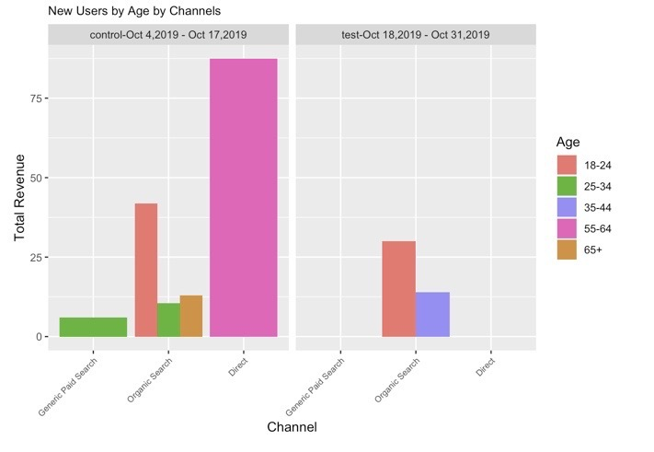

Also, while regressing the test data for New Users to determine the statistical significance, Channels Direct, Branded Paid Search, Age25-34, New Users ,Transactions and E_Conversion Rate are significant.

**Returning Users. Dimensions:** Channel , Age. **Metrics:** Revenue

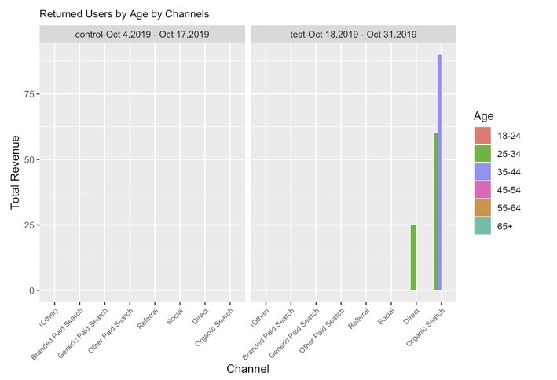

**Figure 8**

Upon regressing the test data for Returning Users, Channels are not significant while Users,Transactions and E_Conversion Rate are significant in Revenue variation.

For New Users, Direct and Paid search for Age 25-34 groups are significant to variation in Revenue, whereas for Returning Users, and Transactions added significance.

#9. **New Users. Dimensions:** Channel , Device **Metrics:** Revenue

While regressing the test data for New Users, Channels Direct and Organic search and Transactions are significant reduction in Revenue variation.

**Returning Users. Dimensions:** Channel , Device **Metrics:** Revenue

**Figure 9**

While regressing the test data for Returning Users, to determine the statistical significance, Channels Organic search and Transactions are significant in Revenue variation.

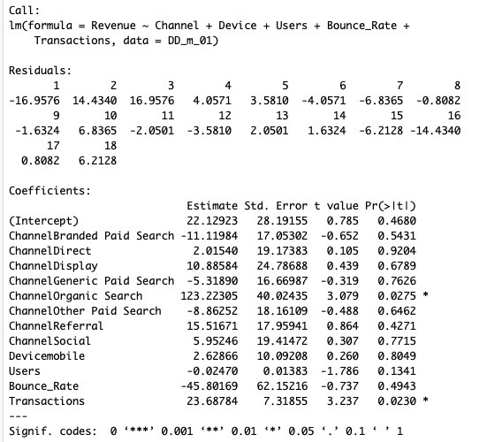

Overall the use of device types on Channels was not significant in both New and Returning Users, but for the Returning Users, Organic Search has a high significance in Revenue variation

**#10. New Users. Dimensions:** Channel , Page **Metrics:** Pageviews

Also, while regressing the New Users test data to determine the statistical significance, Channels Direct, Display, Organic Search and Referral, Entrances and 407 Pages are significant.

**Returning Users. Dimensions:** Channel , Page **Metrics:** Pageviews

**Figure 10**

While regressing the Returning Users test data to determine the statistical significance, Channels Direct, Display, Organic Search, Referral and Social along with 479 Pages are significant.

Pageviews were statistically significant for Organic, Direct, Display and Referral for more variety of pages for both New and Returning Users in the test period.

Earlier in Fig.3, we also saw that Channel Display had the highest bounce rate for both New and returning users,

**#11. New Users. Dimensions:** Channel , Gender **Metrics:** Revenue

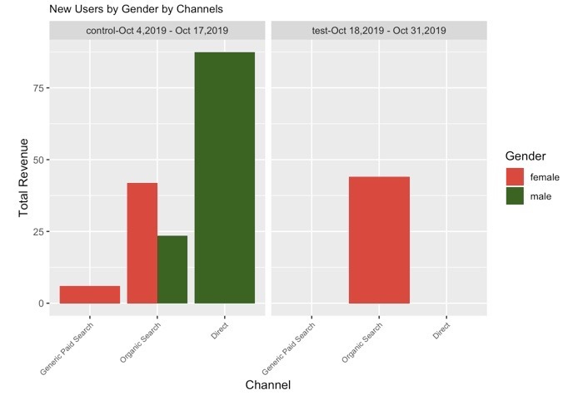

While regressing the test data for New Users to determine the statistical significance, Channels Branded Paid Search, and Transactions are significant in Revenue generation.

**Returning Users. Dimensions:** Channel , Gender **Metrics:** Revenue

**Figure 11**

While regressing the test data for Returning Users, to determine the statistical significance, only Transactions are significant.

Overall, Gender has no statistical significance on the Revenue.

#12. **New Users. Dimensions:** Channel , Source **Metrics:** Revenue

**Returning Users. Dimensions:** Channel , Source **Metrics:** Revenue

**Figure 12**

Revenue generated by Sources for Channels drastically reduced for New Users in test period. Direct and Google are the two prevalent sources for Organic and Direct search.

**#13. New Users Dimensions:** Channel , Advertising Content. **Metrics:** Revenue

While regressing the test data for New Users to determine the statistical significance, Channels Direct and Organic Search and Transactions are significant effect on Revenue.

**Returning Users. Dimensions:** Channel , Advertising Content **Metrics:** Revenue

**Figure 13**

While regressing the test data for Returning Users, only Users are significant.

Organic search is prevalent for Ad-content “not set” though for both New and Returning Users it reduced the Revenue.

**Conversions: Goal 1**

**#14. New Users. Dimensions:** Channel **Metrics**: Purchases completed

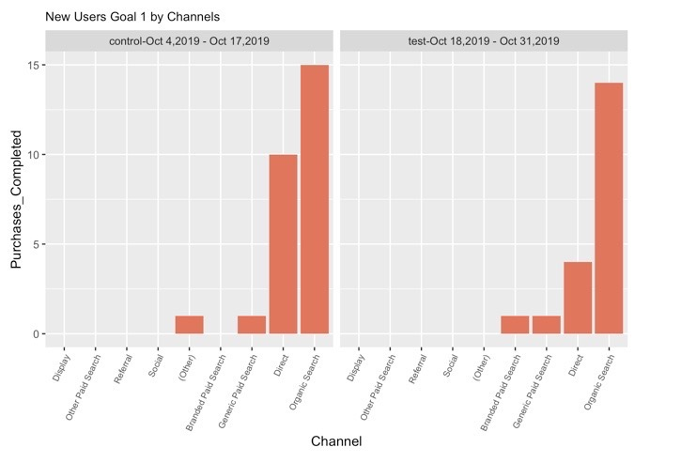

**Returning Users. Dimensions**: Channel. **Metrics**: Purchases completed

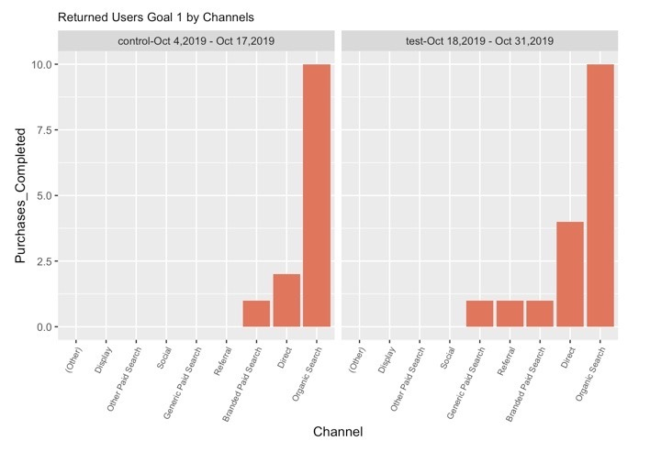

**Figure 14**

For New Users, the Purchases Completed dropped in test period for Organic, Direct, Branded and Generic Paid Search.

The Purchases completed improved for Returning users in test period for Direct and Referrals.

Goal 1 was statistically significant with the presence of New and Returning Users.

**Conversions: Goal 2**

**#15. New Users. Dimensions**: Channel. **Metrics**: Engaged Users

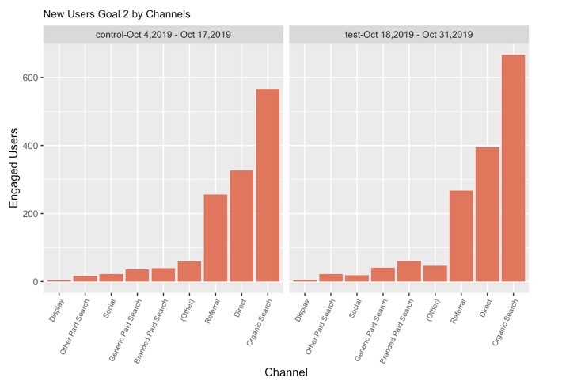

**Returning Users. Dimensions**:Channel. **Metrics**: Engaged Users

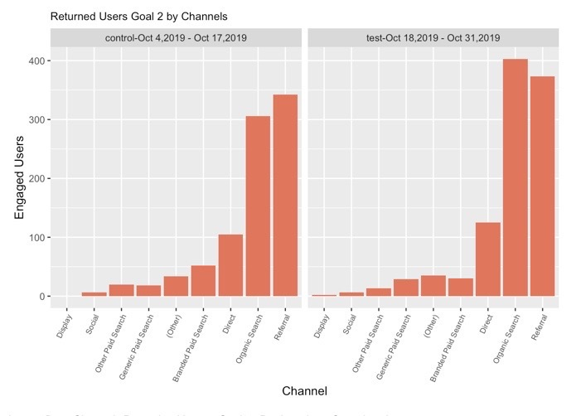

**Figure 15**

Engaged Users increased in both New and Returning Users and Channels Organic Search, Direct, Referral are the most used.

Goal 2 – Variation in Engaged Users were directly dependent on the number of New and Returning Users.

**Conversions: Goal 3**

**#16. New Users. Dimensions**: Channel. **Metrics**: Registrations

**Returning Users. Dimensions**: Channel. **Metrics**: Registrations

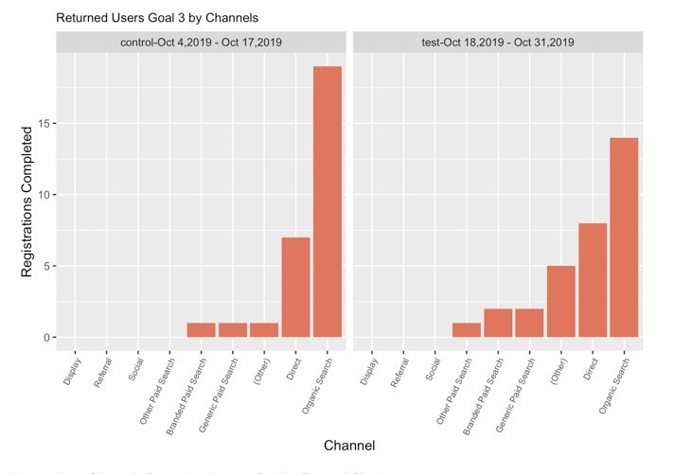

**Figure 16**

Goal 3-Variations in Registrations completed were directly dependent on the number of New and Returning users.

**Conversions: Goal 4**

**#17. New Users. Dimensions**: Channel. **Metrics**: Entered Checkout

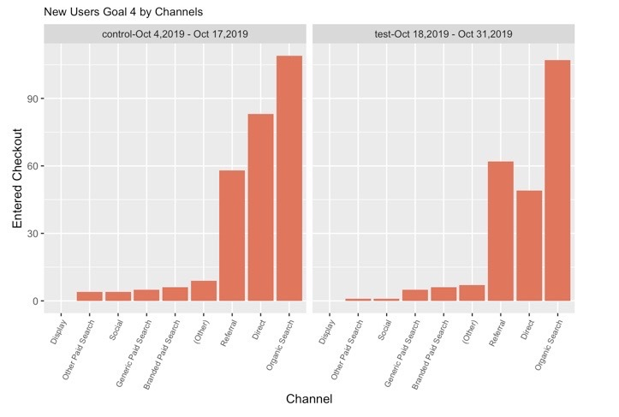

**Returning Users** **Dimensions:** Channel **Metrics**: Entered Checkout

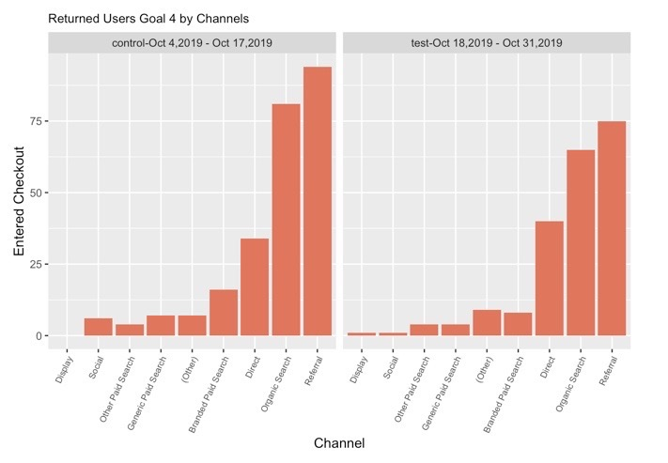

**Figure 17**

Goal 4- Variations in Entered checkout was directly dependent on the number of New and Returned Users.

**Conversions: Goal 5**

**#18. New Users. Dimensions**: Channel **Metrics**: Smart Goals

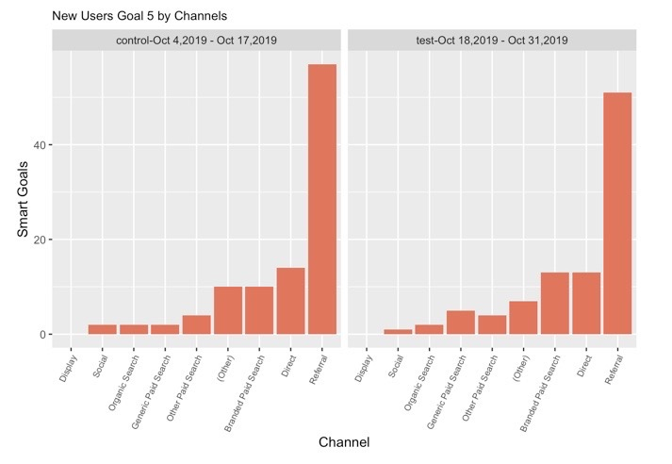

**Returning Users. Dimensions**:Channel.  **Metrics**: Smart Goals

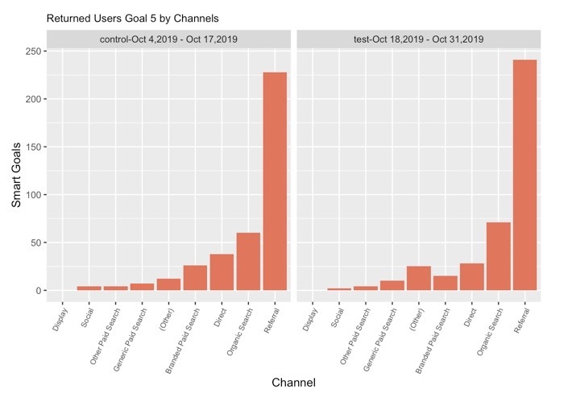

**Figure 18**

Goal 5- There was slight significance of Returning Users in the variation of Smart Goals.

**INFERENCE:**

I took into consideration both New and Returned Users who are potential for the increase in transactions or conversions for various Dimensions as Gender, Age, Hour, City, Country, source, page and ad-content.

Overall, there was an increased level of engagement in New and Returning Users (Fig. 1) and Sessions (Fig. 2), though there was a drastic drop in Revenue in test period (Fig. 4).

Cities also had an increase in New and Returning Users in test period (Fig. 5), though Channels are not significant.

Countries also show an increased involvement with New and Returning users (Fig. 6), and Channel Branded and Generic Paid search has been statistically significant.

Age 25-34 and Channel Paid Search and Direct has significant effect on Revenue (Fig. 8) among New Users.

Gender (Fig. 11), Device (Fig. 9) or Hour (Fig. 7) did not show any statistical significance when regressed with Channel on determining the effect on Revenue.

The Page Views increased with Channels Direct, Display, Organic Search and Referral were significant for more than 400 pages (Fig. 10).

All the conversion Goals, except Smart Goals has Users having significant effect on variations of Purchases completed, Engaged Users , Registrations completed and Entered Checkout. Channels were not significant.

In Figure 3, the Channel Display had the highest bounce rate for both New and Returning users. It may a possible reason that Channel Display couldn’t be resourceful.

As a summary, the following Channels has been influential and can be considered as the top 5 Channels: Organic Search, Direct, Referral , Branded and Generic Paid Search.